**Week 6 :React js**

# **1. React HOL: 1 (myfirstreact)**

**Filename:** App.js

***import*** React ***from*** "react";

***function*** App() {

***return*** (

  <h1> Welcome to the first sesion of React</h1>

  )

}

***export*** ***default*** App;

**Output :**

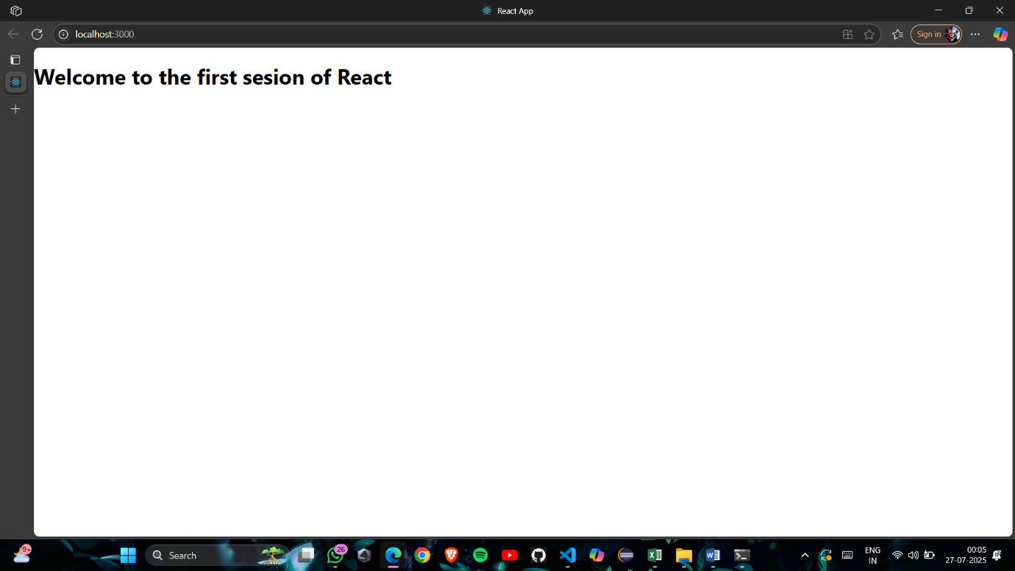

# **2. React HOL: 2 (StudentApp)**

**Filename:** src/Components/Home.js

***import*** React, { Component } ***from*** "react";

***class*** Home **extends** Component {

    render() {

***return*** (

            <div>

                <h3 style***=***{{ textAlign: "center" }}>Welcome to the Home Page of Student Management Portal</h3>

            </div>

        );

    }

}

***export*** ***default*** Home;

**Filename:** src/Components/About.js

***import*** React, { Component } ***from*** "react";

***class*** About **extends** Component {

    render() {

***return*** (

            <div>

                <h3 style***=***{{ textAlign: "center" }}>Welcome to the About Page of Student Management Portal</h3>

            </div>

        );

    }

}

***export*** ***default*** About;

**Filename:** src/Components/Contact.js

***import*** React, { Component } ***from*** "react";

***class***  Contact **extends** Component {

    render() {

***return*** (

            <div>

                <h3 style***=***{{ textAlign: "center" }}>Welcome to the Contact Page of Student Management Portal</h3>

            </div>

        );

    }

}

***export*** ***default*** Contact

;

**Filename:** src/App.js

***import*** './App.css';

***import*** Home ***from*** './Components/Home';

***import*** About ***from*** './Components/About';

***import*** Contact ***from*** './Components/Contact';

***function*** App() {

***return*** (

    <div className ***=*** "container">

      <Home/>

      <About/>

      <Contact/>

    </div>

  );

}

***export*** ***default*** App;

**Output:**

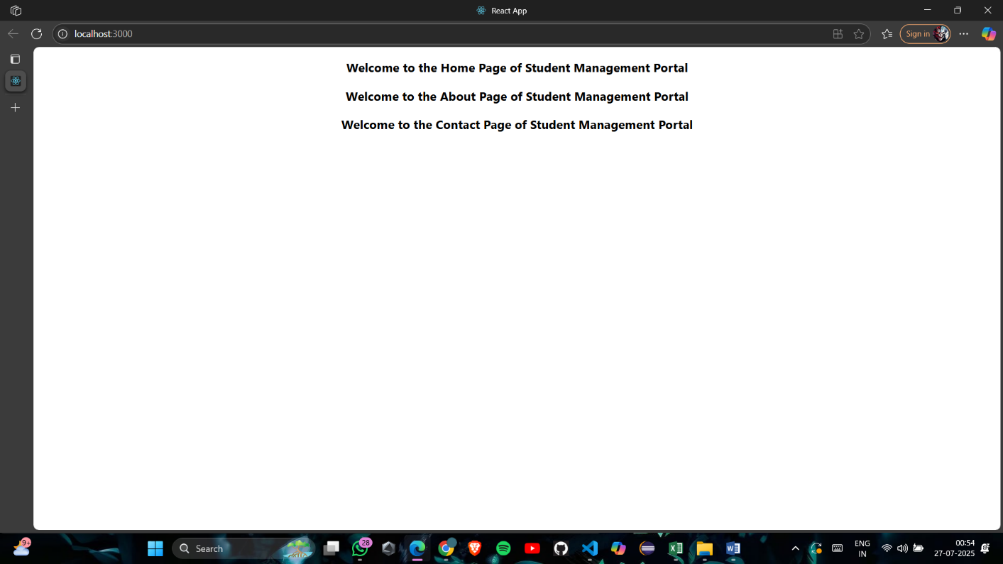

# **3. React HOL: 3 (scorecalculatorapp)**

**Filename:** src/Components/CalculateScore.js

***import*** '../Stylesheets/mystyle.css';

***const*** percentToDecimal ***=*** (decimal) ***=>*** {

***return*** (decimal.toFixed(*2*) ***+*** '%');

};

***const*** calcScore ***=*** (total, goal) ***=>*** {

***return*** percentToDecimal(total ***/*** goal);

};

***export*** ***const*** CalculateScore ***=*** ({ Name, School, total, goal }) ***=>*** (

  <div className***=***"formatstyle">

    <h1 style***=***{{ color: 'brown' }}>Student Details:</h1>

    <div className***=***"Name">

      <b><span>Name: </span></b>

      <span>{Name}</span>

    </div>

    <div className***=***"School">

      <b><span>School: </span></b>

      <span>{School}</span>

    </div>

    <div className***=***"Total">

      <b><span>Total:</span></b>

      <span>{total}</span>

      <span> Marks</span>

    </div>

    <div className***=***"Score">

      <b>Score:</b>

      <span>{calcScore(total, goal)}</span>

    </div>

  </div>

);

**Filename:** src/StyleSheets/mystyle.css

.Name {

  font-weight: *300*;

  color: blue;

}

.School {

  color: crimson;

}

.Total {

  color: darkmagenta;

}

.formatstyle {

  text-align: center;

  font-size: large;

}

.Score {

  color: forestgreen;

}

**Filename:** src/App.js

***import*** './App.css';

***import*** { CalculateScore } ***from*** './Components/CalculateScore';

***function*** App() {

***return*** (

    <div>

<CalculateScore Name***=***{"Steeve"}

School***=***{"DNV Pubblic School"}

total***=***{*248*}

goal***=***{*3*}

/>

    </div>

  );

}

***export*** ***default*** App;

**Output:**

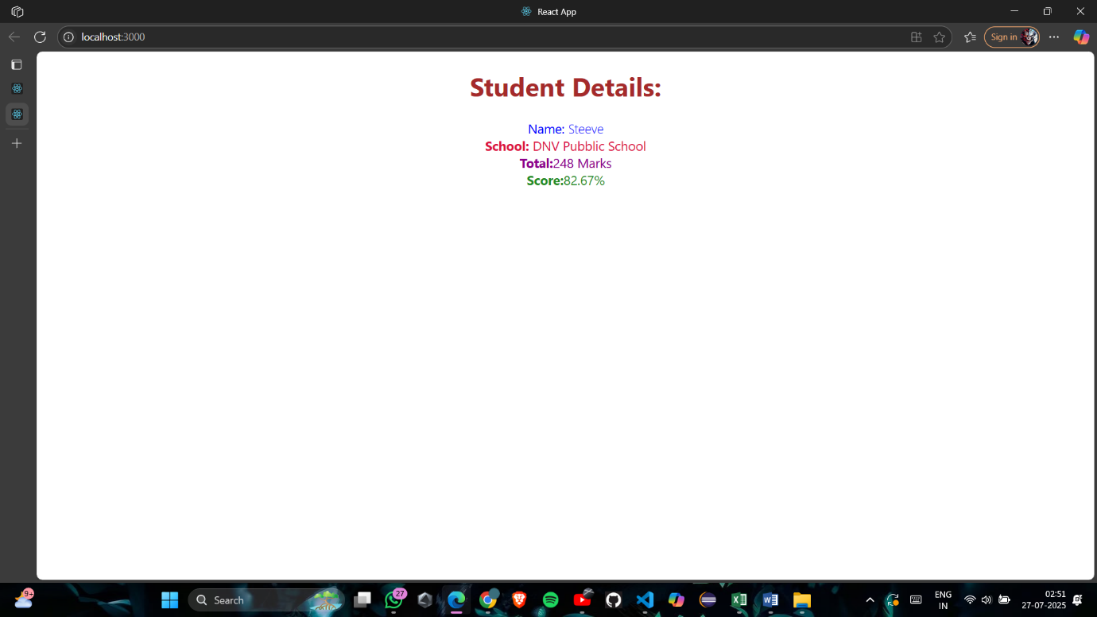

# 4. React HOL: 4(blogapp)

**Filename:** Post.js

***class*** Post{

***constructor***(id, title,body){

*this*.id ***=*** id;

*this*.title ***=*** title;

*this*.body ***=*** body;

    }

}

***export*** ***default*** Post;

**Filename:** Posts.js

***import*** React ***from*** 'react';

***import*** Post ***from*** './Post';

***class*** Posts **extends** React.Component {

***constructor***(props) {

        super(props);

*this*.state ***=*** {

            posts: [],

            hasError: false

        };

    }

**async** loadPosts() {

***try*** {

***const*** response ***=*** ***await*** fetch("https://jsonplaceholder.typicode.com/posts");

***const*** data ***=*** ***await*** response.json();

***const*** postObjects ***=*** data.map(item ***=>*** ***new*** Post(item.id, item.title, item.body));

*this*.setState({ posts: postObjects });

        } ***catch*** (error) {

            console.error("Fetch error:", error);

*this*.setState({ hasError: true });

        }

    }

    componentDidMount() {

*this*.loadPosts();

    }

    render() {

***if*** (*this*.state.hasError) {

***return*** <h1>Something went wrong!</h1>;

        }

***return*** (

            <div>

                <h1>Blog Posts</h1>

                {*this*.state.posts.map(post ***=>*** (

                    <div key***=***{post.id}>

                        <h2>{post.title}</h2>

                        <p>{post.body}</p>

                    </div>

                ))}

            </div>

        );

    }

    componentDidCatch(error, info) {

        alert("An error occurred while rendering the component.");

        console.error("Error caught:", error, info);

    }

}

***export*** ***default*** Posts;

**Filename:** App.js

***import*** React ***from*** 'react';

***import*** './App.css';

***import*** Posts ***from*** './Posts';

***function*** App() {

***return*** (

    <div className***=***"App">

      <Posts />

    </div>

  );

}

***export*** ***default*** App;

**Output:**

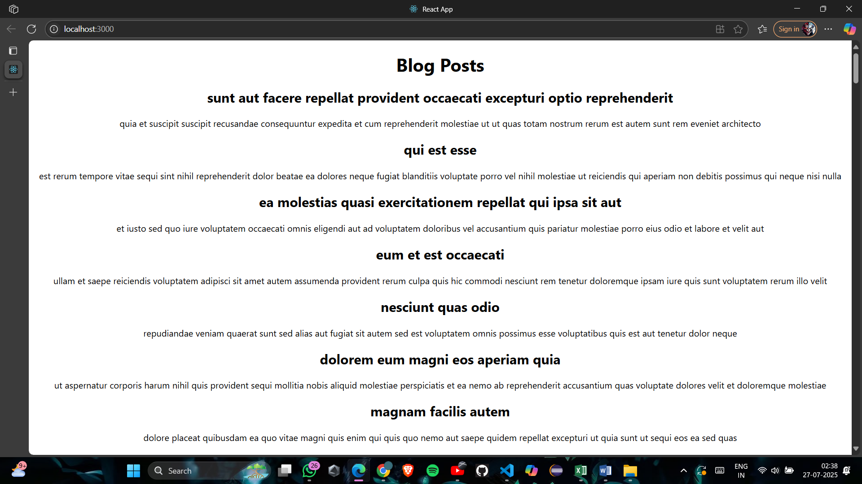

# 5. React HOL: 5(cohorttracker)

**Filename:** CohortDetails.js

***import*** React ***from*** 'react';

***import*** styles ***from*** './CohortDetails.module.css';

***function*** CohortDetails(props) {

***const*** { cohort } ***=*** props;

***const*** headingStyle ***=*** {

    color: cohort.currentStatus ***===*** 'Ongoing' ***?*** 'green' ***:*** 'blue'

  };

***return*** (

    <div className***=***{styles.box}>

      <h3 style***=***{headingStyle}>

        {cohort.cohortCode} - <span>{cohort.technology}</span>

      </h3>

      <dl>

        <dt>Started On</dt>

        <dd>{cohort.startDate}</dd>

        <dt>Current Status</dt>

        <dd>{cohort.currentStatus}</dd>

        <dt>Coach</dt>

        <dd>{cohort.coachName}</dd>

        <dt>Trainer</dt>

        <dd>{cohort.trainerName}</dd>

      </dl>

    </div>

  );

}

***export*** ***default*** CohortDetails;

**Filename:** CohortDetails.module.css

.box {

  width: *300px*;

  display: inline-block;

  margin: *10px*;

  padding: *10px* *20px*;

  border: *1px* solid black;

  border-radius: *10px*;

}

dt {

  font-weight: *500*;

}

**Filename:** Cohort.js

***class*** Cohort {

***constructor***(cohortCode,

        startDate,

        technology,

        trainerName,

        coachName,

        currentStatus) {

*this*.cohortCode ***=*** cohortCode;

*this*.coachName ***=*** coachName;

*this*.trainerName ***=*** trainerName;

*this*.technology ***=*** technology;

*this*.startDate ***=*** startDate;

*this*.currentStatus ***=*** currentStatus;

    }

}

***const*** CohortsData ***=***[

***new*** Cohort('INTADMDF10','22-Feb-2022', '.NET FSD', 'Jojo Jose','Aathma', 'Scheduled'),

***new*** Cohort('ADM21JF014','10-Sep-2021', 'Java FSD', 'Elisa Smith','Apoorv', 'Ongoing'),

***new*** Cohort('CDBJF21025','24-Dec-2021', 'Java FSD', 'John Doe','Aathma', 'Ongoing'),

***new*** Cohort('INTADMJF12','22-Feb-2022', 'Java FSD', 'To Be Assigned','Ibrahim', 'Scheduled'),

***new*** Cohort('CDE22JF011','24-Dec-2021', 'Java FSD', 'Emma Swan','Apoorv', 'Ongoing'),

***new*** Cohort('INTADMDF09','22-Feb-2022', 'Dataware Housing', 'Babjee Rao','Aathma', 'Scheduled'),

***new*** Cohort('ADM22DF001','10-Sep-2021', '.NET FSD', 'Marie Curie','Ibrahim', 'Ongoing'),

];

***export*** {Cohort, CohortsData};

**Filename:** App.js

***import*** logo ***from*** './logo.svg';

***import*** './App.css';

***import*** { CohortsData} ***from*** './Cohort'

***import*** CohortDetails ***from*** './CohortDetails';

***function*** App() {

***return*** (

  <div>

    <h1>Cohorts Details</h1>

    {CohortsData.map(cohort ***=>*** <CohortDetails cohort***=***{cohort}/>)}

  </div>

  );

}

***export*** ***default*** App;

**Output:**

